

Practices for Secure Software Report

Table of Contents
Document Revision History 3
Client 3
Instructions 3
Developer 4
1. Algorithm Cipher 4
2. Certificate Generation 4
3. Deploy Cipher 4
4. Secure Communications 4
5. Secondary Testing 4
6. Functional Testing 4
7. Summary 4
8. Industry Standard Best Practices 4

Document Revision History

Version | Date | Author | Comments
1.0 | 10/16/2026 | Kyle Payne

Client



Instructions

Submit this completed practices for secure software report. Replace the bracketed text with the relevant information. You must document your process for writing secure communications and refactoring code that complies with software security testing protocols.

- Respond to the steps outlined below and include your findings.
- Respond using your own words. You may also choose to include images or supporting materials. If you include them, make certain to insert them in all the relevant locations in the document.
- Refer to the Project Two Guidelines and Rubric for more detailed instructions about each section of the template.

Developer
Kyle Payne

Algorithm Cipher

I recommend AES-256 in Galois/Counter Mode (GCM) to protect Artemis Financial’s financial information. AES encrypts the data, and GCM detects unauthorized changes. AES-256 uses a 256-bit key and processes 128-bit blocks, providing strong protection for sensitive customer information (OWASP Foundation, n.d.).

For this project, I implemented SHA-256 for checksum verification and HTTPS for secure communication. SHA-256 is a hash function, not an encryption cipher. It produces a 256-bit checksum displayed as 64 hexadecimal characters. Comparing a recalculated checksum with a trusted original helps detect changes, but hashing does not encrypt the data.

AES uses symmetric encryption, meaning the same secret key encrypts and decrypts data. Asymmetric cryptography uses a public and private key pair, such as the 3072-bit RSA pair used by my certificate. Encryption keys require cryptographically secure random numbers, and GCM requires an initialization vector that is never reused with the same key. SHA-256 needs no key or random value because identical data must produce the same checksum (OWASP Foundation, n.d.).

NIST standardized AES in 2001 after a public competition. Its documentation was updated in 2023 without changing the algorithm and AES remains an approved encryption standard. This supports using established cryptography to protect Artemis Financial’s information (National Institute of Standards and Technology, 2023).

Certificate Generation

I used Java Keytool through Eclipse to generate a self-signed certificate for localhost with a 3072-bit RSA key and a SHA256withRSA signature. I stored the key and certificate in artemis-local.p12 and exported the certificate as artemis-local.cer. The screenshot shows the certificate before I added it to my local trusted certificate store for HTTPS testing.
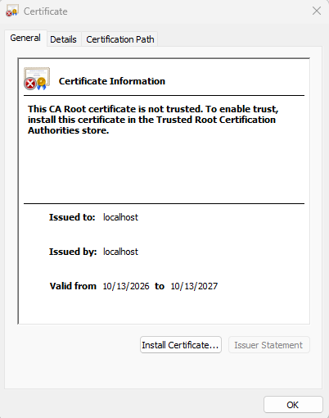

Deploy Cipher

I added the /hash endpoint to generate a SHA-256 checksum from the unique string “Kyle Payne | Artemis Financial | Project Two | 2026-10-13.” The code uses UTF-8 encoding and returns my name, the data, the algorithm and also the checksum. An independent SHA-256 calculation matched the displayed checksum, confirming the result was correct.

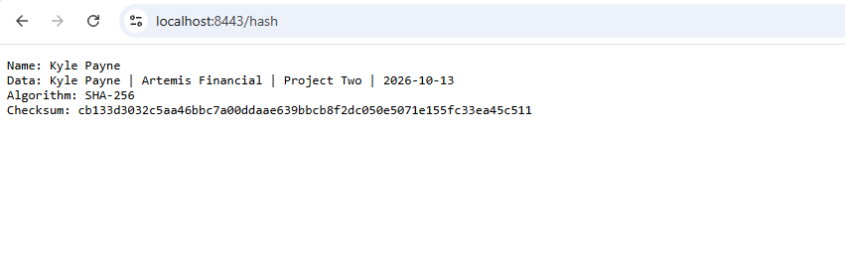

Secure Communications

I configured application.properties to enable HTTPS on port 8443 using the PKCS12 keystore and the artemis key alias. The keystore password is supplied through an environment variable instead of being written in the configuration file. After starting the application I opened https://localhost:8443/hash in Chrome. The endpoint displayed the checksum, and Chrome confirmed “Connection is secure.”

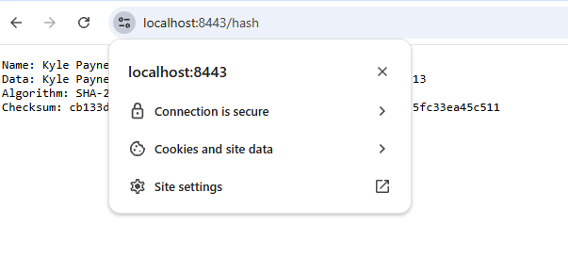

Secondary Testing

I ran OWASP Dependency-Check 13.0.0 through Maven after refactoring and then the build completed successfully. The report identified 14 vulnerable dependencies with 254 reported findings in libraries already included in the supplied code base. My changes used Java’s built in hashing classes and existing Spring components without adding application dependencies. I reviewed the findings within the assignment’s scope and documented the existing library risks. A successful build does not mean the application has no vulnerabilities!

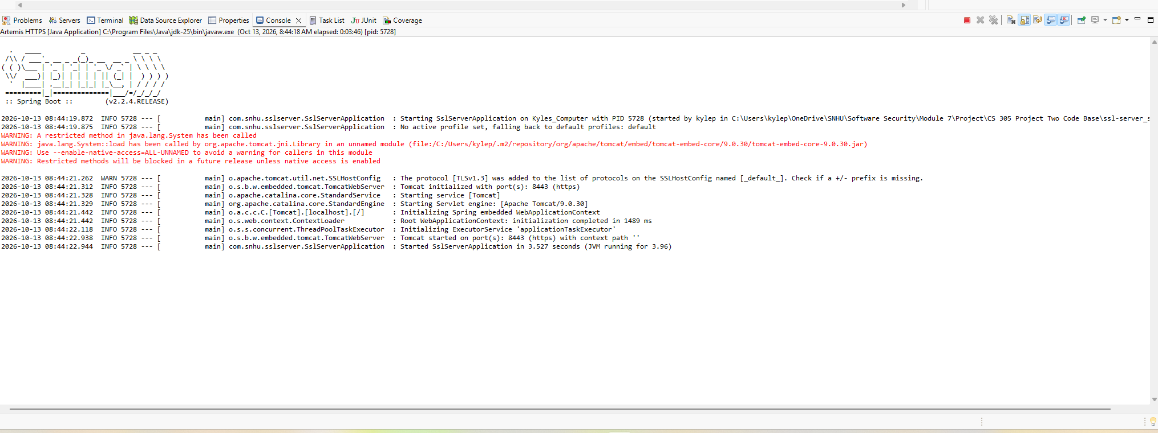

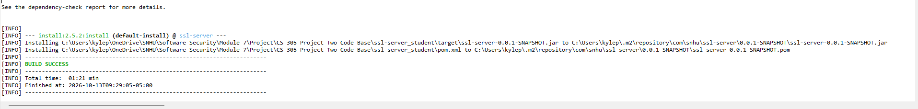

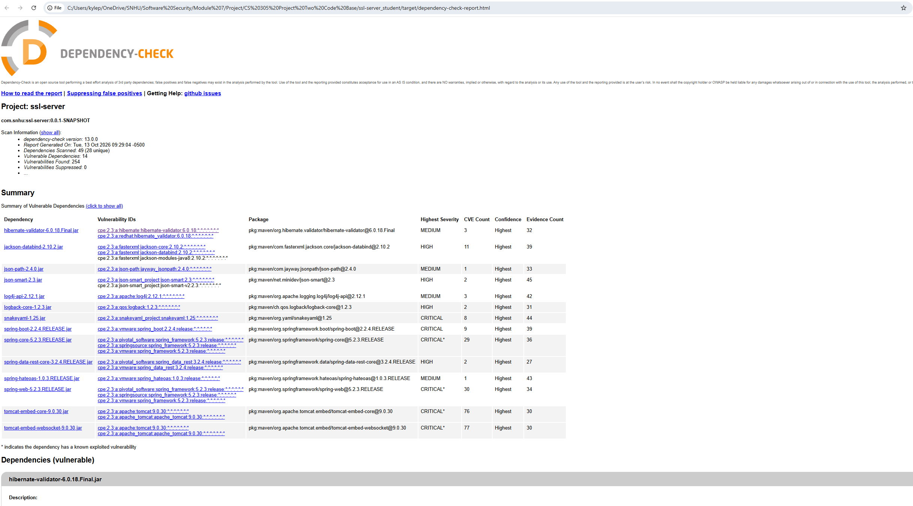

Functional Testing

I manually reviewed the added Java code and HTTPS settings for syntax errors, logic errors, and security issues. I checked the UTF-8 encoding, SHA-256 calculation, hexadecimal output, and external keystore password configuration. The code creates a separate MessageDigest for each request and returns only fixed demonstration data. The Maven application context test passed and then the browser displayed the correct checksum over HTTPS. I found no syntax errors, logic errors, or even security issues in the reviewed changes.

Summary

Using the vulnerability assessment process flow diagram I focused on cryptography, client/server, APIs and code quality. I added SHA-256 checksum generation to the /hash endpoint, configured HTTPS, and kept the keystore password outside the source code. These changes provide separate layers for checking data integrity, encrypting communication, and protecting credentials.
I checked the changes through manual code review, maven testing, browser verification, and a dependency check. The application ran successfully and returned the correct checksum over HTTPS. I also documented the existing dependency vulnerabilities. The refactored files are SslServerApplication.java, application.properties, and pom.xml.

Industry Standard Best Practices

I used Java’s built in cryptographic classes, enabled HTTPS, and supplied the keystore password through an environment variable. Using established cryptographic tools and protecting secrets follows industry guidance (OWASP Foundation, n.d.). I also checked application startup, then verified the checksum, and then reviewed dependencies after refactoring to identify security problems while preserving existing functionality.
These practices help Artemis Financial protect customer information and detect problems before deployment. Consistent secure coding and testing reduce the risk of data breaches, service interruptions and also costly repairs. They also help protect customer trust and the company’s reputation.

References

National Institute of Standards and Technology. (2023). Advanced encryption standard (AES). https://doi.org/10.6028/NIST.FIPS.197-upd1

OWASP Foundation. (n.d.). Cryptographic storage cheat sheet. https://cheatsheetseries.owasp.org/cheatsheets/Cryptographic_Storage_Cheat_Sheet.html

